PUBLICITY ACTIVITY

Chosen Career:

Educational Path required:

Advantages of this educational path:

Advantages of the job:
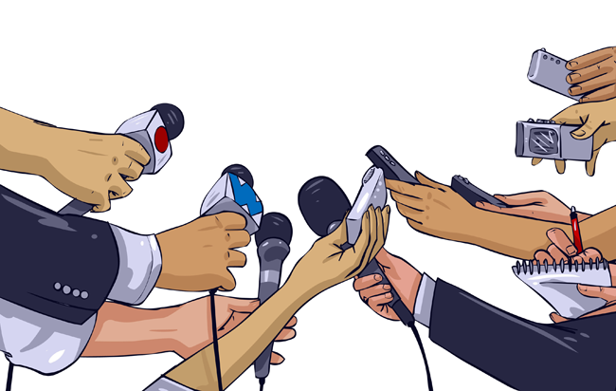

Publicity method (keep in mind that you will need to produce this advertisement) Can be a poster/article/clip:

Target market:

