TITLE & HYPERLINK | SUMMARY | ACTUS REUS | MENS REA
1) Simon Gittany sentenced to at leasy 18 years for fiancee Lisa Harnum's murder | Gittany has been sent to prison for a minimum 18 year non-parole period for throwing Lisa Harnums body from their 15th floor Hyde Park apartment in 2011. | Gittany physically picked up Lisa and threw her over the balcony. | Gittany did not want Lisa to leave him. There is camera footage of him grabbing her by the face and pulling her inside.
2)
3)
4)
5)
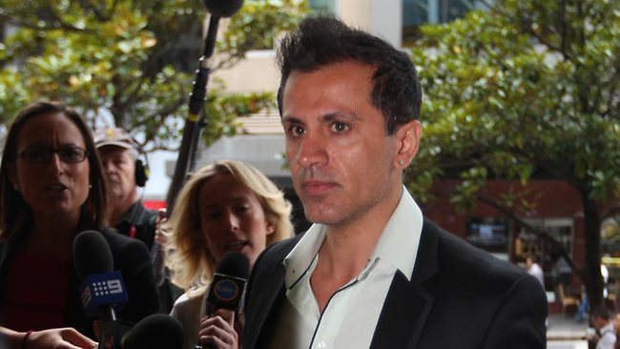
ELEM ENTS OF A CRIME - Research

