FINANCIAL STATEMENTS

– In Detail
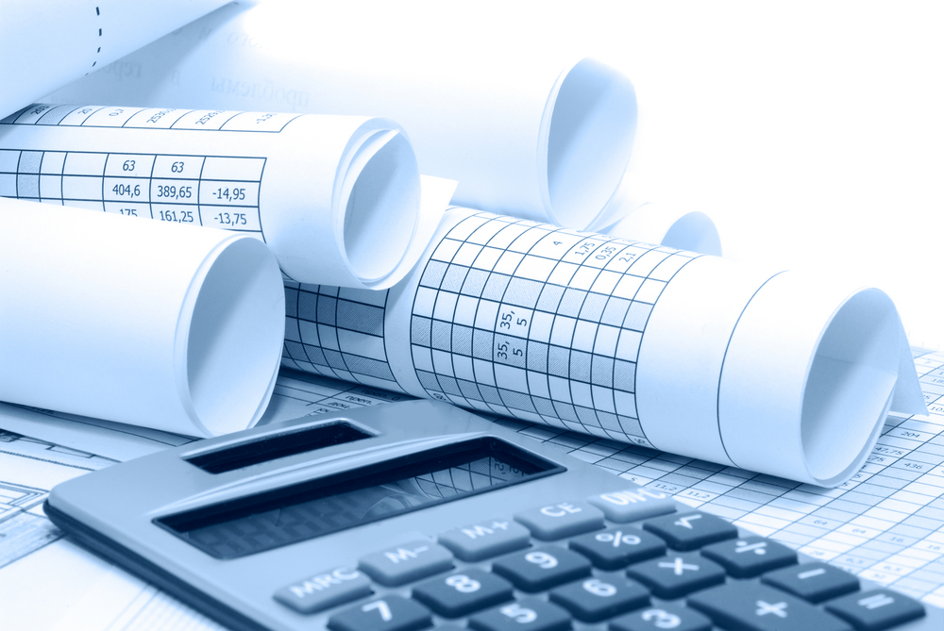

Quick Summary
Small businesses need to keep detailed records of the inflow and outflow of funds in their business so that they may track the success of the business and also for taxation purposes.
The three types of financial statements that we will be looking at are:
- Revenue Statement
- Balance Sheet
- Cash flow statement

Important Terms
The following is a list of terms that are important to know when working on financial statements. We will discuss these terms as we move through the worksheet.

Revenue expenses gross profit/loss
Net profit/loss assets liabilities
Owner’s equity liquidity

Revenue Statement
Businesses use revenue statements to measure their revenue against their expenses to figure out how much profit they are making.
Important equations in a revenue statement are:
Revenue – Cost of Goods Sold= Gross Profit
Gross Profit- Expenses = Net Profit

Revenue: The income earned by a business
Expenses: costs incurred in running the business
Gross Profit/loss: the amount remaining when the cost of goods sold is deducted from revenue
Net Profit/loss: the amount remaining when operating expenses are deducted from gross profit

- What might be some expenses that a business might incur?
- _____________________________________________________
- _____________________________________________________
- _____________________________________________________
- _____________________________________________________

Some things to remember when drawing up a Revenue Statement:
- There should be 3 columns
- The first column should hold the name of the cost or expense
- The second column should include the monetary figures related to the business’s expenses
- The third column should include the monetary figures related to the business’s revenue
- The third column should also include all the TOTALS , this includes the total gross profit, the total expenses and the total net profit

An example of a REVENUE STATEMENT
Revenue statement for the year ending 30 June 2012
 | $ | $
Revenue
Cash sales |  | 215,000
Less Cost of Goods Sold |  | 90,000
Gross Profit |  | 125,000
Less Expenses
Wages | 38,000
Rent | 20,000
Electricity | 5,500 | 63, 500
Net Profit |  | 61,500

Further Examples – Complete the Revenue Statements for the following businesses. Determine whether they have experienced a profit or loss for the year ending 30th June.
Sam’s Sports
- Cash Sales $230,000
- Cost of Goods Sold $125,000
- Wages $40,000
- Lease Payments $15,675
- Electricity $5,500
- Promotions $2, 760
- Insurance $4,900

 | $ | $
Gloria’s Coffee Corner
- Cash Sales $195,000
- Cost of Goods Sold $46,700
- Lease Payments $15,000
- Electricity $9050
- Free Samples $1,550
- Advertising $5,500
- Interest on Loan $4,565
 | $ | $

Matt’s Mechanic
- Cost of Goods Sold $280,000
- Gross Profit $450,000
- Wages $150,000
- Lease Payments $30,580
- Electricity $12,000
- Advertising $5,000
- Insurance $5,500

 | $ | $

Diana’s Home Depot
- Cost of Goods Sold $75,080
- Gross Profit $128,000
- Wages $42,000
- Lease Payments $17,000
- Equipment $5,000
- Electricity $7,000
- Advertising $4,560
- Insurance $3,750
- Interest on Loan $4,590
 | $ | $

Jayden’s Juice Store
- Cost of Goods Sold $380,000
- Gross Profit $440,000
- Wages $160,000
- Lease Payments $20,580
- Electricity $16,000
- Advertising $6,000
- Insurance $7,500
 | $ | $

- What is the main use of revenue statement?
______________________________________________________________________________________________________________________________________________________
- Construct a set of steps that somebody who doesn’t know much about revenue statements can use to construct one.
_______________________________________________________________________________________________________________________________________________________________________________________________________________________________________________________________________________________________________________________________________________________________________________________

Construct your very own Revenue Statement

Name of Business:

List of Revenue and Expenses

Revenue Statement:
 | $ | $

Balance Sheet
The balance sheet shows the statement of financial position of a business at a particular time. It can be thought of as a set of scales which weights what you own (assets) on one side and what you owe (liabilities) on the other. Both sides must balance
The most important equation in a balance sheet is:
Owner’s Equity= Assets- Liabilities

OR
Assets= Owner’s Equity + Liabilities

Owner’s Equity: the value of the business to the owner
Assets: items of value owned by the business
Liabilities: debts owed by a business to others

Some things to remember when drawing up a Cash Flow Statement:
- The left hand side of the balance sheet shows assets
- The right hand side of the balance sheet shows liabilities and owners equity
- Classify balance sheet items into one of the following categories
- Assets (Current or non-current)
- Liabilities (current or non-current)
- Owner’s Equity
- All statistics for each sub-topic should be written in the left-hand column of the appropriate section (assets, liabilities or owners’ equity)
- All totals for each section should be written in the right hand column of the appropriate section (assets, liabilities or owner’s equity).
- When all balance sheet items are entered on the balance sheet, both sides should have the same total.
- When determining the value of the owner’s equity, add up all items in the assets column, record the same total in the liabilities column, then subtract whatever liabilities are listed from the “Total liabilities and owners equity” figure.

Important Terms Continued

Examples of Current Assets

Examples of Non-Current Assets

Examples of Current Liabilities

Examples of Non-Current Liabilities

Examples of Owner’s Equity

Example of a BALANCE SHEET
Assets | $ | $ | Liabilities | $ | $
Current Assets  Cash at bank  Stock on hand | 68,000  22,300 |  | Current Liabilities  Accounts payable |  | 35,000
Total |  | 90,300 | Total |  | 35,000
Non-Current Assets  Equipment  Motor Vehicle  Glasses and Cutlery | 58,00  37,000  12,500 |  | Non-current liabilities  Bank loan |  | 55,000
 |  |  | Total |  | 55,000
 |  |  | Owner’s Equity  Net Profit Retained  Capital | 61,500  46,300
Total |  | 107,500 | Total |  | 107,800
Total Assets |  | 197,800 | Total liabilities and owners equity |  | 197,800

Further Examples – Complete the Balance Sheets for the following businesses. Determine whether they have experienced a profit or loss for the year ending 30th June.
Paul’s Pizza

- Cash $450
- Creditors $2,400
- Mortgage $10,000
- Pizza Ovens $1,500
- Loan $680
- Stock $550
- Delivery Vehicles $15,000
- Capital $4,420

Assets | $ | $ | Liabilities | $ | $
Current Assets |  |  | Current Liabilities
Total |  |  | Total
Non-Current Assets |  |  | Non-current liabilities
 |  |  | Total
 |  |  | Owner’s Equity
Total |  |  | Total
Total Assets |  |  | Total liabilities and owners equity

Ben’s Bakery

- Creditors $23,000
- Cash at bank $8,000
- Goodwill $2,000
- Capital $13,500
- Building $4000
- Ovens $3,500
- Accounts receivable $23,500
- Profit $9,500
- Shares(in a company) $5000

Assets | $ | $ | Liabilities | $ | $
Current Assets |  |  | Current Liabilities
Total |  |  | Total
Non-Current Assets |  |  | Non-current liabilities
 |  |  | Total
 |  |  | Owner’s Equity
Total |  |  | Total
Total Assets |  |  | Total liabilities and owners equity

Frank’s Pharmacy

- Owner’s investment $10,000
- Bank loan $18,000
- Cash $15,000
- Equipment $4,500
- Stock $5,500
- Accounts payable $15,000
- Debtors $8,000
- Premises $10,000

Assets | $ | $ | Liabilities | $ | $
Current Assets |  |  | Current Liabilities
Total |  |  | Total
Non-Current Assets |  |  | Non-current liabilities
 |  |  | Total
 |  |  | Owner’s Equity
Total |  |  | Total
Total Assets |  |  | Total liabilities and owners equity

Sally’s Sports

- Debtors $15,000
- Owner’s Investment $3,500
- Creditors $21,000
- Cash at Bank $8,000
- Building $10,000
- Bank Loan $4,500
- Stock $1,500
- Accounts payable $9,000
- Goodwill $3,500

Assets | $ | $ | Liabilities | $ | $
Current Assets |  |  | Current Liabilities
Total |  |  | Total
Non-Current Assets |  |  | Non-current liabilities
 |  |  | Total
 |  |  | Owner’s Equity
Total |  |  | Total
Total Assets |  |  | Total liabilities and owners equity

Danny’s Deli

- Cash in store $6000
- Owner’s investment $8,505
- Debtors $5,100
- Building $5,000
- Bank Loan $15,000
- Creditors $2,745
- Profit $3,500
- Stock $6,500
- Cash at Bank $20,100
Assets | $ | $ | Liabilities | $ | $
Current Assets |  |  | Current Liabilities
Total |  |  | Total
Non-Current Assets |  |  | Non-current liabilities
 |  |  | Total
 |  |  | Owner’s Equity
Total |  |  | Total
Total Assets |  |  | Total liabilities and owners equity
- Capital $26,000
- Accounts payable $3,500
- Accounts receivable $7,300
- Goodwill $1250
- Shares $3000
- Equipment $5000

Cash Flow Statements
A cash flow statement is used to keep track of the movement of cash within a business. By regularly comparing cash inflows and cash outflows a business is able to calculate its surplus or deficit cash. This is an important indicator of a business’s liquidity.
Some important equations to remember when drawing up a cash flow statement is:
Net Cash Flow= Total Cash Inflow – Total Cash Outflow

Closing Cash Balance= Opening Cash Balance + Net Cash Flow

Cash inflows: Money received by an organization as a result of its operating activities, investment activities, and financing activities. Money coming in.
Cash outflows: Money paid out by an organization as a result of its operating activities, investment activities, and financing activities. Money going out.
Net Cash flow: Total Cash inflow minus the Total Cash Outflow
Opening cash balance: The cash already existing within the business. The closing cash balance from the previous cash flow statement.
Closing cash balance: This is the Opening Cash Balance plus the Net Cash Flow.
Steps to remember to when drawing up a Cash Flow Statement:
- Calculate the total cash inflows by adding up all the cash coming IN to the business.
- Calculate the total cash outflows by adding up all the expenses of the business.
- Calculate the Net cash flow (Total Cash Inflow minus Total Cash Outflow)
- Calculate the Closing Cash Balance (Net Cash Flow + Opening Cash Balance)

How to set out a Cash flow statement:
- There should be 3 Columns
- The first column contains all the headings/labels.
- The second column contains all the monetary figures of things such as cash inflows and cash outflows
- The third column contains all the totals: total cash inflows, total cash outflows, net cash flow, opening cash balance and closing cash balance.

Example of a Cash Flow Statement

Sam’s Soccer Boots
Cash flow statement for the year ending 30 June 2012
Net Operating Activities- 75,300 Wages – 38,000
Borrowed Funds- 55,000 Rent – 20,000
Opening Cash Balance – 11,000 Electricity- 5,500
 | $ | $
Cash Inflows
Net Operating Activities | 75,300
Borrowed Funds | 55,000
Total cash inflows |  | 130,300
Cash outflows
Wages | 38,000
Rent | 20,000
Electricity | 5,500
Total cash outflows |  | 63,500
Net cash flow (TCI-TCO) |  | 66,500
Opening cash balance |  | 11,000
Closing cash balance |  | 77,500

Further Examples – Complete the Balance Sheets for the following businesses. Determine whether they have experienced a profit or loss for the year ending 30th June.

Peter’s Paint Store
- Net Operating Activities $85,000
- Borrowed Funds $65,000
- Wages $20,000
- Rent $15,000
- Electricity $6000
- Maintenance $4000
- Opening Cash Balance $10,000
 | $ | $

Sam’s Skateboard Store
- Net Operating Activities $65,000
- Borrowed Funds $75,000
- Wages $30,000
- Paint Supplies $6000
- Rent $12,000
- Electricity $4000
- Maintenance $2000
- Opening Cash Balance $12,000
 | $ | $

Tim’s tutoring
- Net Operating Activities $85,000
- Borrowed Funds $15,000
- Wages $35,000
- Stationary Supplies $8000
- Rent $13,500
- Electricity $4000
- New Furniture $7000
- Opening Cash Balance $21,000
 | $ | $

Adam’s Aussie Restaurant
- Net Operating Activities $105,000
- Borrowed Funds $11,000
- Wages $25,000
- Ingredients $18,000
- Rent $17,500
- Electricity $7000
- New Tables and Chairs $7000
- Opening Cash Balance $52,000
 | $ | $

Tanya’s Telecommunications
- Net Operating Activities $305,000
- Borrowed Funds $17,000
- Wages $75,000
- New Display cabinets $11,000
- Rent $23,500
- Electricity $12,000
- Glass Cleaner’s fee $7000
- Opening Cash Balance $22,000
 | $ | $

